**Team Name:** Team A

**Team Members:** Roberto M. Prisoris Jr.  
Kit Adrian B. Diocares  
Jenny Babe C. Arac  
Shannen G. Mendoza

**Hello World**

*[Log in Testing]*

1. 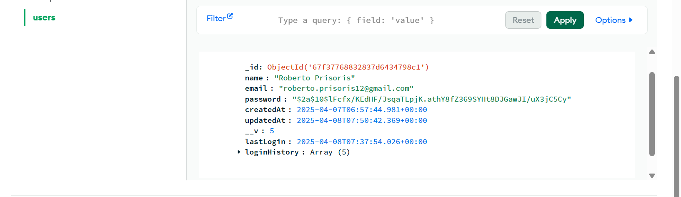Log In Collection
2. Initial Login Screen

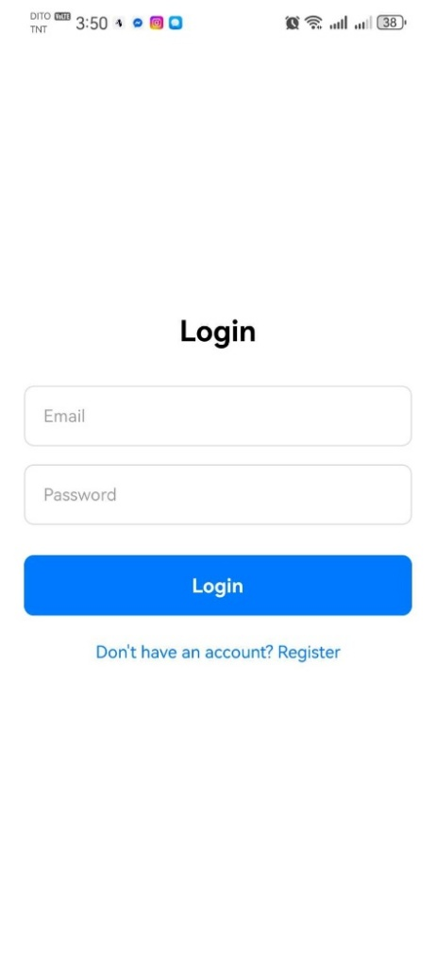

1. 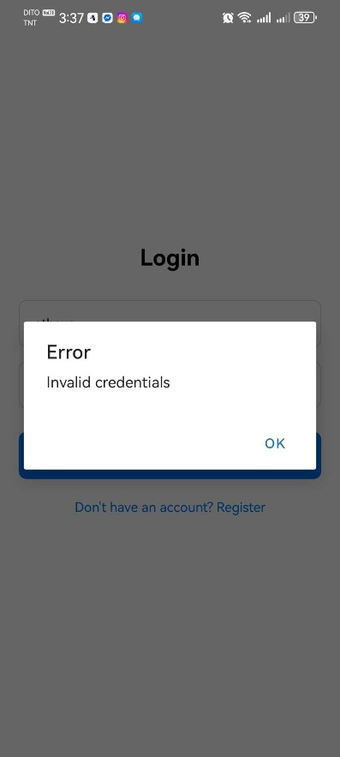Testing Failed Login
   1. 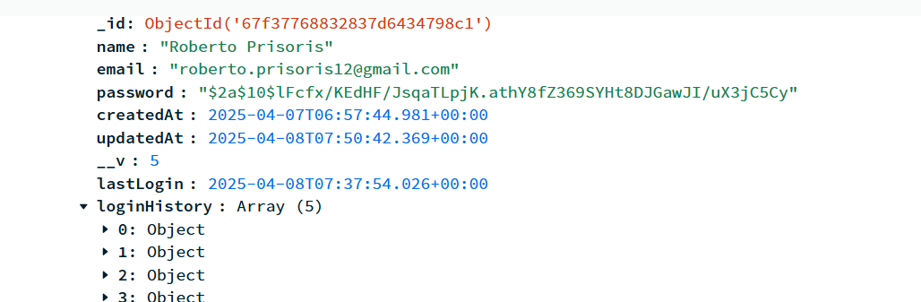There are no changes after the login failed
2. 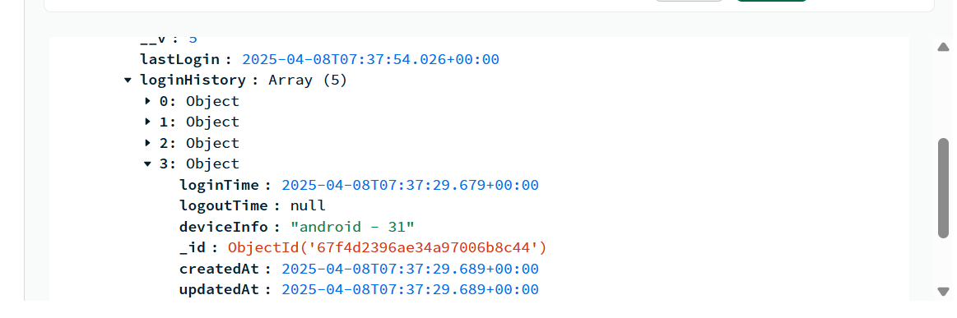Testing Successful Login and Logout [*Collection Logs*]  
     
     
     
   1. 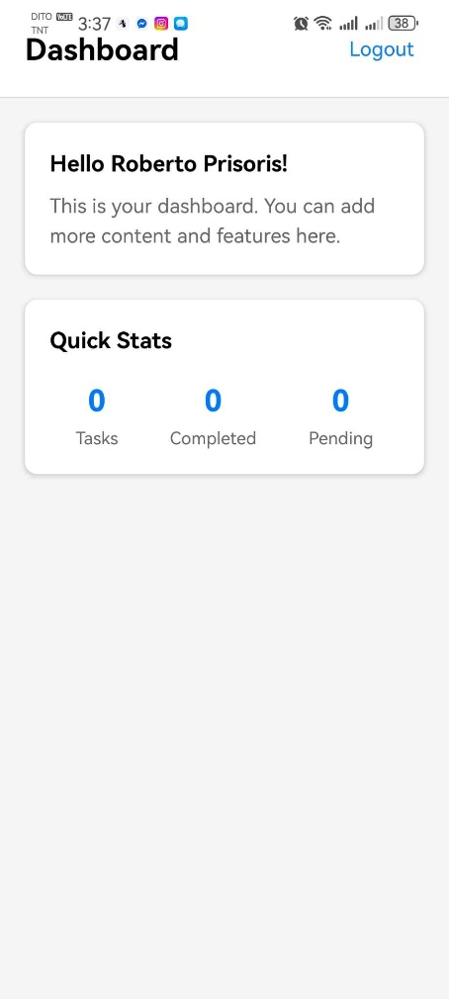It will go directly to Dashboard after a successful Login